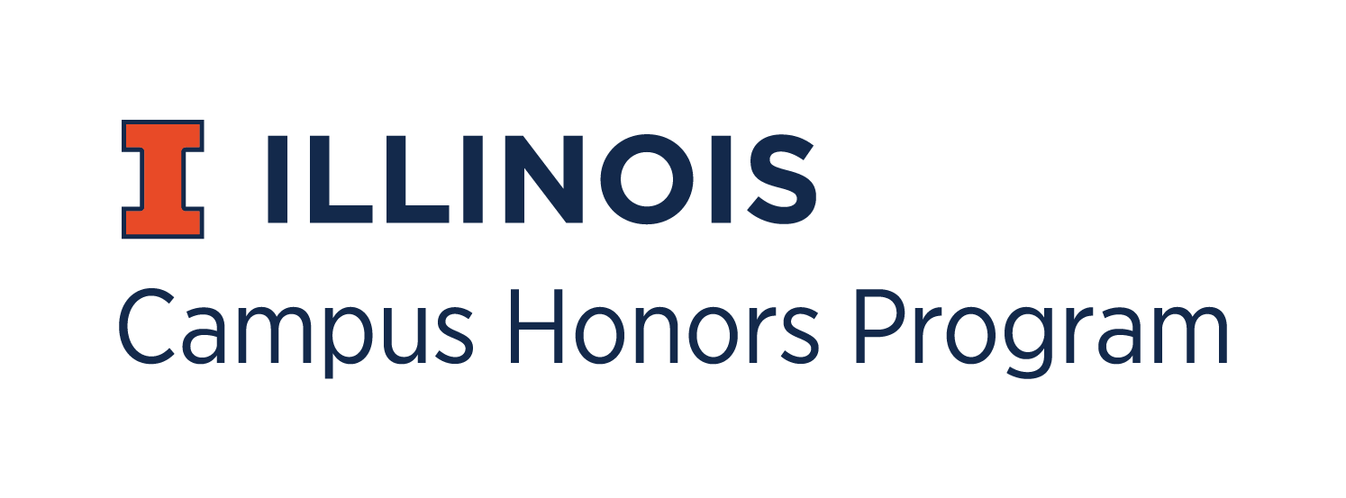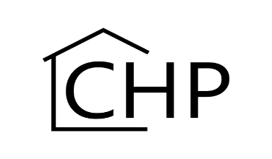
Study Abroad Course Substitution Form

Students may petition to waive either one CHP course or the capstone course for participation in another substantive academic experience, such as study abroad. Please email completed form to chp@illinois.edu or deliver to the Campus Honors House at 1205 W Oregon in Urbana.

Student Name: Click or tap here to enter text.

UIN: Click or tap here to enter text.

Today’s Date: Click or tap to enter a date.

Semester and Academic Year of the Study Abroad Experience: Click or tap here to enter text.

City, Country, University of the Study Abroad Experience: Click or tap here to enter text.

Sponsoring Organization for the Study Abroad Program: Click or tap here to enter text.

For CHP Use Only

Campus Honors Program Approval:
Date:

College Approval:
Date:

