Intercultural Study Tour to London

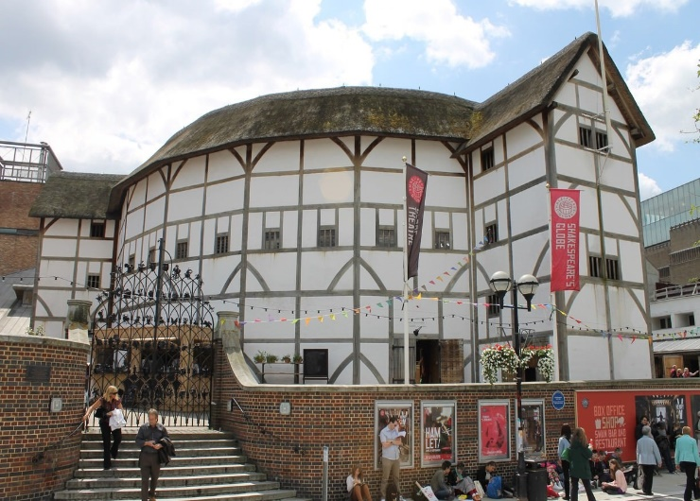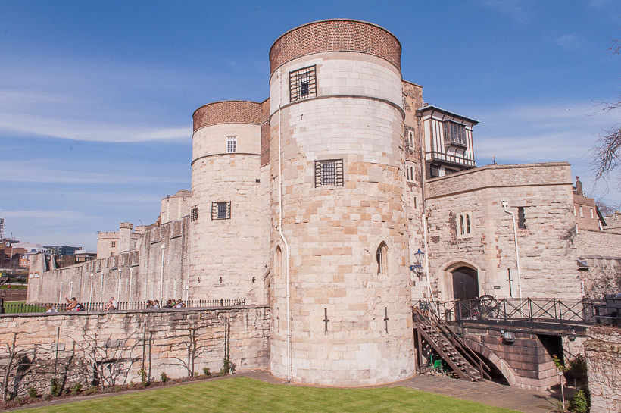
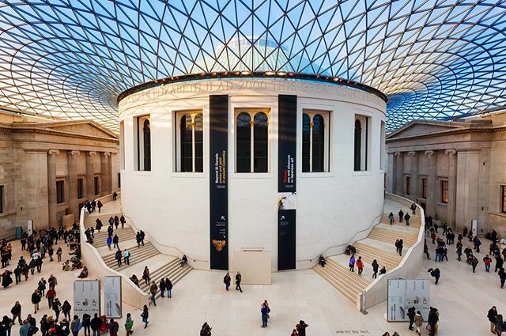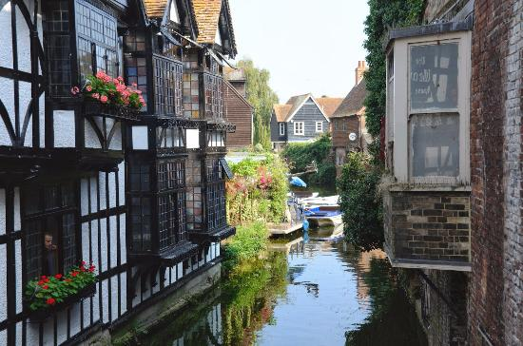
Literary London: A Tour of English Theatre and Culture
ENGL 199 CRN 70946 May 18 - 28, 2020

Join Professor Andrea Stevens (English) on this immersion into the theatre and culture of London, England. From its medieval origins, the West End has evolved into one of the world’s premier theater and entertainment districts.

Students will engage with their surroundings via a range of activities, including guided tours, walking tours, free-writing sessions, museum visits, and trips to see current shows at different venues both commercial and avant-garde or experimental. Our home base will be as close as possible to the historic “Southwark” area of London, near the site of the Globe Theatre, the Borough Market, and the Tate Modern. Our time together will also allow for one day trip to the UNESCO World Heritage site Canterbury in Kent.

