EXCLUSIVE CHP TRIP TO PERU
MAY 14-25, 2018

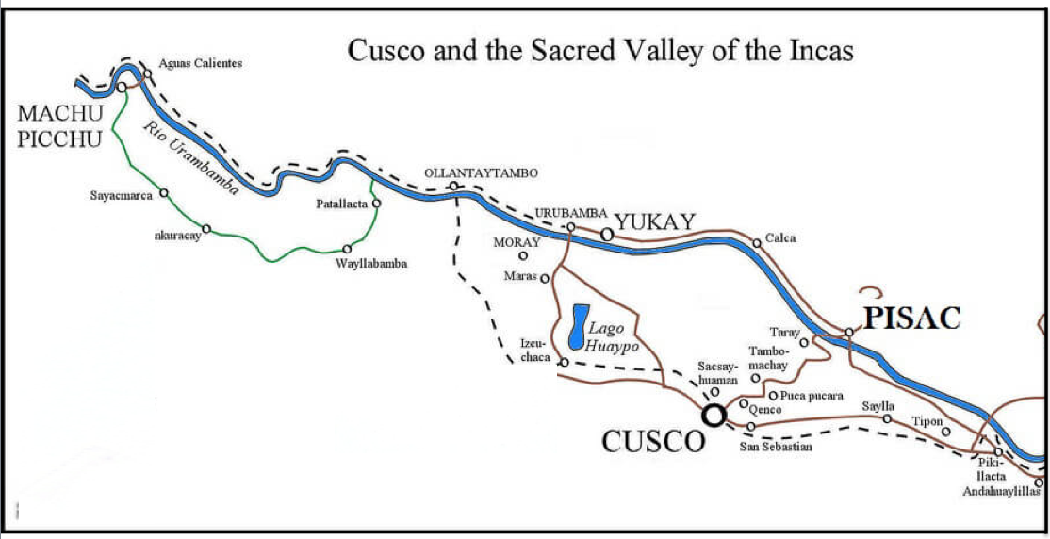

Join Professor Helaine Silverman (Anthropology) on this thrilling exploration of the heartland of the ancient Inca Empire. See its heritage expressed by the descendants of that great Andean society. Visit spectacular ruins, including the renowned “lost city” of Machu Picchu. Fly over the snow-capped Andes mountains. Travel on one of the most scenic train rides in the world. See the beautiful colonial churches built by the Spanish conquerors in Cuzco, the former Inca capital and today the epicenter of global tourism. Learn about the politics and policies of tourism and heritage management that promote economic development in this stunning highland region. Sample the delicious cuisine of Peru, which has achieved global acclaim. Stay in unique hotels. Participate in many interactions with local people. Finish the trip with two fascinating days in Peru's capital city, Lima, where we continue our time-travel through the heritage and economic development of the pre-Columbian, colonial and modern city. Enjoy a special tour of the UNESCO-designated historic center and a full day at a restored hacienda. Professor Silverman spent the first half of her adult life in Peru working as an archaeologist and since then has conducted many years of contemporary heritage research there. This experience offers an insider's view of Peru.

For more academic information and Peru details contact Professor Silverman
helaine@illinois.edu

For CHP information contact Anne Price in the CHP office

ITINERARY

MONDAY, May 14, 2018
Fly from Chicago to Lima via Dallas or Miami on American Airlines. It is an overnight flight to Lima.

TUESDAY, May 15, 2018
- Arrive in Peru in the early morning. 3-4 hours in airport to clear customs and immigration. Queue for flight to Cuzco. Fly to Cuzco. OBLIGATORY TO REST.
- 3 p.m. LUNCH
- Walking tour of Plaza de Armas.
- Orientation from Helaine about the next day as we finish the tour.
- Dinner on their own. Eat lightly. Nothing fried. No alcohol. Go to bed early.
- OVERNIGHT: Hotel Los Los Apus, Cuzco

WEDNESDAY, May 16, 2018
- BUS until lunch
- Morning: Sacsayhuaman Kenko-Tambo Machay-Puca Pucara
- On the way down, stop at San Cristobal Church for view
- LUNCH (this is where bus leaves us)
- Coricancha (entrada)
- Catedral del Cuzco (entrada) or Iglesia de la Compañía (entrada)
- San Blas
- 6 p.m. at hotel: Orientation from Helaine about the next day
- Dinner on their own
- OVERNIGHT: Hotel Los Apus, Cuzco

THURSDAY, MAY 17, 2018
- Bus all day. Leave Cuzco.
- Chinchero – Maras – Moray
- LUNCH BUFFET TUNUPA URUBAMBA
- Late arrival at Ollantaytambo
- DINNER AT HOTEL PACARIQTAMBO RESTAURANT with orientation about the next day from Helaine
- OVERNIGHT: Hotel Pacariqtambo, Ollantaytambo

FRIDAY, MAY 18, 2018
- Morning: explore the beautiful ruins of Ollantaytambo
- LUNCH IN HOTEL
- Afternoon: explore the living town of Ollantaytambo within the Inca walls. ChocoMuseo.
- 6 p.m. Orientation for Machu Picchu the next day
- Dinner on their own
- OVERNIGHT: Hotel Pacariqtambo, Ollantaytambo

SATURDAY, MAY 19, 2018
- Morning train PeruRail VISTADOME to Machu Picchu
- Noon: LUNCH BUFFET
- Visit MACHU PICCHU ruins.
- 7 p.m. Orientation at the hotel about the next day
- Dinner on their own.
- OVERNIGHT: Hotel in Machu Picchu pueblo

SUNDAY, May 20, 2018
- Train back to Ollantaytambo.
- Bus all day. Bus picks us up in Ollantaytambo to return to Cuzco.
- Señora que prepara la chicha (if she is open on Sunday)
- Urubamba: Taller Seminario (fine craft ceramics)
- LUNCH IN MUSEO INKARIY (DE LOS MÉRIDA).
- Visit Museo Inkariy.
- Pisaq ruins OR Pisaq market.
- Visit Amana Kancha to see the llamas (if open).
- Hotel to rest.
- 7 p.m. DINNER: Los Toldos Pollos a la Brasa. Orientation by Helaine about next day.
- OVERNIGHT: Hotel Los Apus, Cuzco

MONDAY, May 21, 2018
- Bus until return to Cuzco after lunch.
- Optional for those who wish to go with Helaine at 7 a.m.: Mercado San Pedro.
- Bus. 9 a.m.: Bus takes us to Calle Meloc for candles.
- 10:30 a.m.: Tipón and Andahuaylillas
- LATE LUNCH (“picnic” que llevamos con nosotros: agua, pan, chocolate, queso, plátano)
- Stop at Rumicolca briefly for explanation. Stop at Oropesa for bread.
- Hotel.
- OPTIONAL: You are welcome to come with me to Pisco Bar in Cuzco where I buy pisco.
- 7:30 p.m. DINNER WITH SHOW AT TUNUPA ON PLAZA DE ARMAS
- (At restaurant before dinner: orientation by Helaine about next day)
- OVERNIGHT: Hotel Los Apus, Cuzco. Go to bed early.

TUESDAY, May 22, 2018
- Bus takes up to airport. Leave Cuzco. Early flight to Lima.
- Lima: Bus picks us up and stays with us till hotel check-in.
- Walking tour of the historic center of Lima.
- 1:30 p.m. LUNCH AT HUACA PUCLLANA
- Tour Huaca Pucllana and little site museum
- 4:30 p.m.: CHECK IN AT HOTEL. Helaine gives orientation about next day.
- 6 p.m. OPTIONAL: Walk to artesanías on Petit Thouars with Helaine -- last chance to purchase souvenirs
- Dinner on their own.
- OVERNIGHT: Hotel in Miraflores, Lima

WEDNESDAY, May 23, 2018
- Bus pickup at Larco Mar after lunch and it stays with us through dinner.
- 9 a.m. Morning: walking tour of Miraflores: Parque Kennedy, Larco, Malecón, Parque del Amor, Casa de Julio C. Tello, end at Larco Mar
- 12 p.m. LUNCH in Larco Mar
- 2 p.m. Museo de Arte de Lima (MALI)/Museum of Art
- 4 p.m. Barranco
- 6 p.m. OPTIONAL: Go to a supermarket with Helaine
- 8 p.m. DINNER: CHIFA

THURSDAY, May 24, 2018
- NOTE: we all keep our hotel rooms as if staying overnight even though we are not.
- Bus all day. Special event: Travel to the next valley south of Lima (Lurín) to Los Ficus. Learn about the conversion of the former hacienda to a cultural heritage center and recreo. Training and performance of the world-renowned Peruvian caballos de paso.
- LUNCH at Los Ficus. Gourmet traditional Peruvian food.
- Return to hotel. Get organized.
- Leave hotel at 7 p.m. for airport. End of bus, end of Happy Tours services.
Fly overnight, arriving home on Friday, May 25.

